

SRA Final Report instructions and template – DELETE INSTRUCTIONS BEFORE SUBMITTING

Introduction
Final reports are an essential output of the project process. The final report provides accountability to those investing in the project. It also helps document the methods, data, insights of the work undertaken and help subsequent research and adoption activities. It should be a stand-alone document and capture the key background, methods, data, analyses, interpretations and conclusions from the research project. Previous milestone reports are not publicly available and should not be referenced in the final report; relevant information from milestone reports must be incorporated in the final report. Please use appendices for large data sets and additional information. Final reports will be published on the SRA website unless confidentiality is requested.

Cover page
- Insert company logo and any co-funder organisation logos in the picture placeholders at the bottom right beside the SRA logo. Right click and select ‘Change picture’. Delete extra placeholders.
- If the report is not confidential, remove ‘Confidential’ and remove ‘Date of public access.’

General style guidelines
- Use styles as set up in ‘SRA’ pre-set styles in formatting ribbon.
- Arial (Body), font 9 for standard text (Body Copy).
- Arial (Headings), font 11, bold for Heading 1 (Heading 1).
- Arial (Headings), font 9, bold for Heading 2 (Heading 2).
- Arial (Headings), font 9 bold for Heading 3 (Heading 3).
- Page/header and footer, Arial (Body), font 9 (Body Copy).

Header and Footer
- Ensure that the header does not start until the third page (Section 2). Add the SRA project code (formatted as 201x/xxx) right aligned. If confidential, include “- SRA Confidential” in the header following the project code.
- Do not change the page number formatting.

Table of Contents
- Right click within Table of Contents area and click, “Update Field > Update entire table”.

Figures
- In the text use the abbreviated style of Fig. 1 and in captions, Figure 1.
- Captions for figures should be directly below the figure and should be hyperlinked using the “References > Insert Caption” option.
- If required, insert Table of Figures on page 4 using “References > Insert Table of Figures”.
- Right click within Table of Figures area and click, “Update Field > Update entire table”.
- For Figure Titles, use Arial, font 9, bold. Use pre-set style ‘Heading 6,Figure’. Use “CAPTION, SRA CAPTION” for figure details (so it doesn’t pull ALL of the figure text into the Table of Figures.)
- Space figures 6pt before and 12pt after. Left align figures.

Tables
- In the text within tables, use the “Table data” pre-set style. In captions refer to tables as Table x (e.g. Table 1). Captions for tables should be directly above the table and should be hyperlinked using the “References > Insert Caption” option.
- If your table has a heading, use “Table Heading”. Use “Table Data Heading” for row/column titles.
- Table of Tables is on page 4. Right click within Table of Tables area and click, “Update Field > Update entire table”. Delete table if not required.
- For Tables caption, use Arial, font 9, bold. See pre-set style ‘SRA Caption’.
- Space figures 12pt before and 6pt after. Left align tables.

Paragraph
- For standard paragraph text use single line spacing, 0pt spacing before, 10pt spacing after. See pre-set style “Body Copy”.
- One return between paragraphs.
- Left align all paragraphs.

Footnotes
- If required, footnotes should appear at the bottom of the page using References > Insert Footnote or below the table or chart to which they refer.


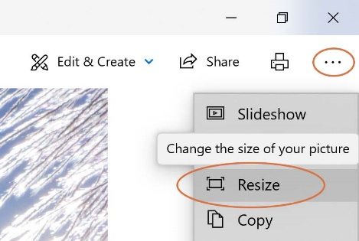
Inserting images
- If you have access to Photoshop or similar image editing software, compress images to 96ppi (print quality) to reduce file size.
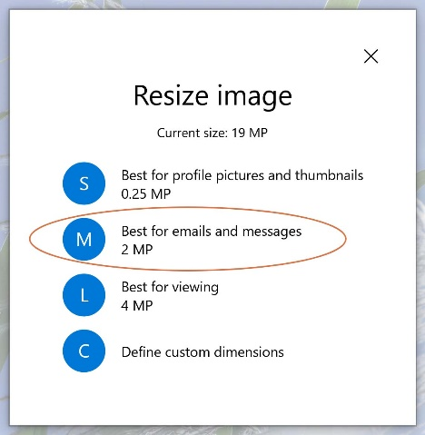
- Alternatively, open your image in the “Photos” app in Windows, and select the three dots in the top right hand corner and choose Resize. Choose the medium option, save, and insert this version into your report.
- Only insert images that are in jpeg format.
- Following ‘figure’ formatting instructions.

IP register
- It is a requirement of submission that the SRA IP portal has an updated version of the project’s IP disclosure and that a pdf version of the IP disclosure if submitted alongside the Final Report. Contact ipportal@sugarresearch.com.au if you require assistance.
- If the project was contracted prior to 2017, the word document version of the IP register must be attached.

Videos
Submit video as a separate file attached to final report submission and not embedded in final report.

Watermark
Add ‘CONFIDENTIAL’ watermark to all versions if confidential.

Data storage information
SRA requires information about the nature of the data used within this project and the storage and accessibility of said data in the future. Please fill out tables in template appendix providing this information. Delete if no data used in project and therefore not required.

Saving and file names
- Save the file as ‘ProjectCode FinalReport V1.0’
- If the report is confidential, add “- SRA Confidential” to file name
- Submit the final report as a Word file.

Citations
- Reference citations are to be cited in accordance with the Harvard system of referencing. See https://web.library.uq.edu.au/files/26535/harvard-2002-style-guide.pdf
- Please insert citation for Final Report in the placeholder at the bottom of the disclaimer page including those who have made significant contributions to the work as authors.

Report submission
- File size should be no more than 10MB.
- SRA will insert ISBN into placeholder on page 2 after submission if required.

CHECKLIST PRIOR TO SUBMISSION
- Final report is in Word as per formatting instructions. Submit Word document version.
- Intellectual Property (IP) disclosure pdf is attached to submission. (Word document version if project contracted prior to 2017).
- Financial Acquittal template has been passed on to relevant department.

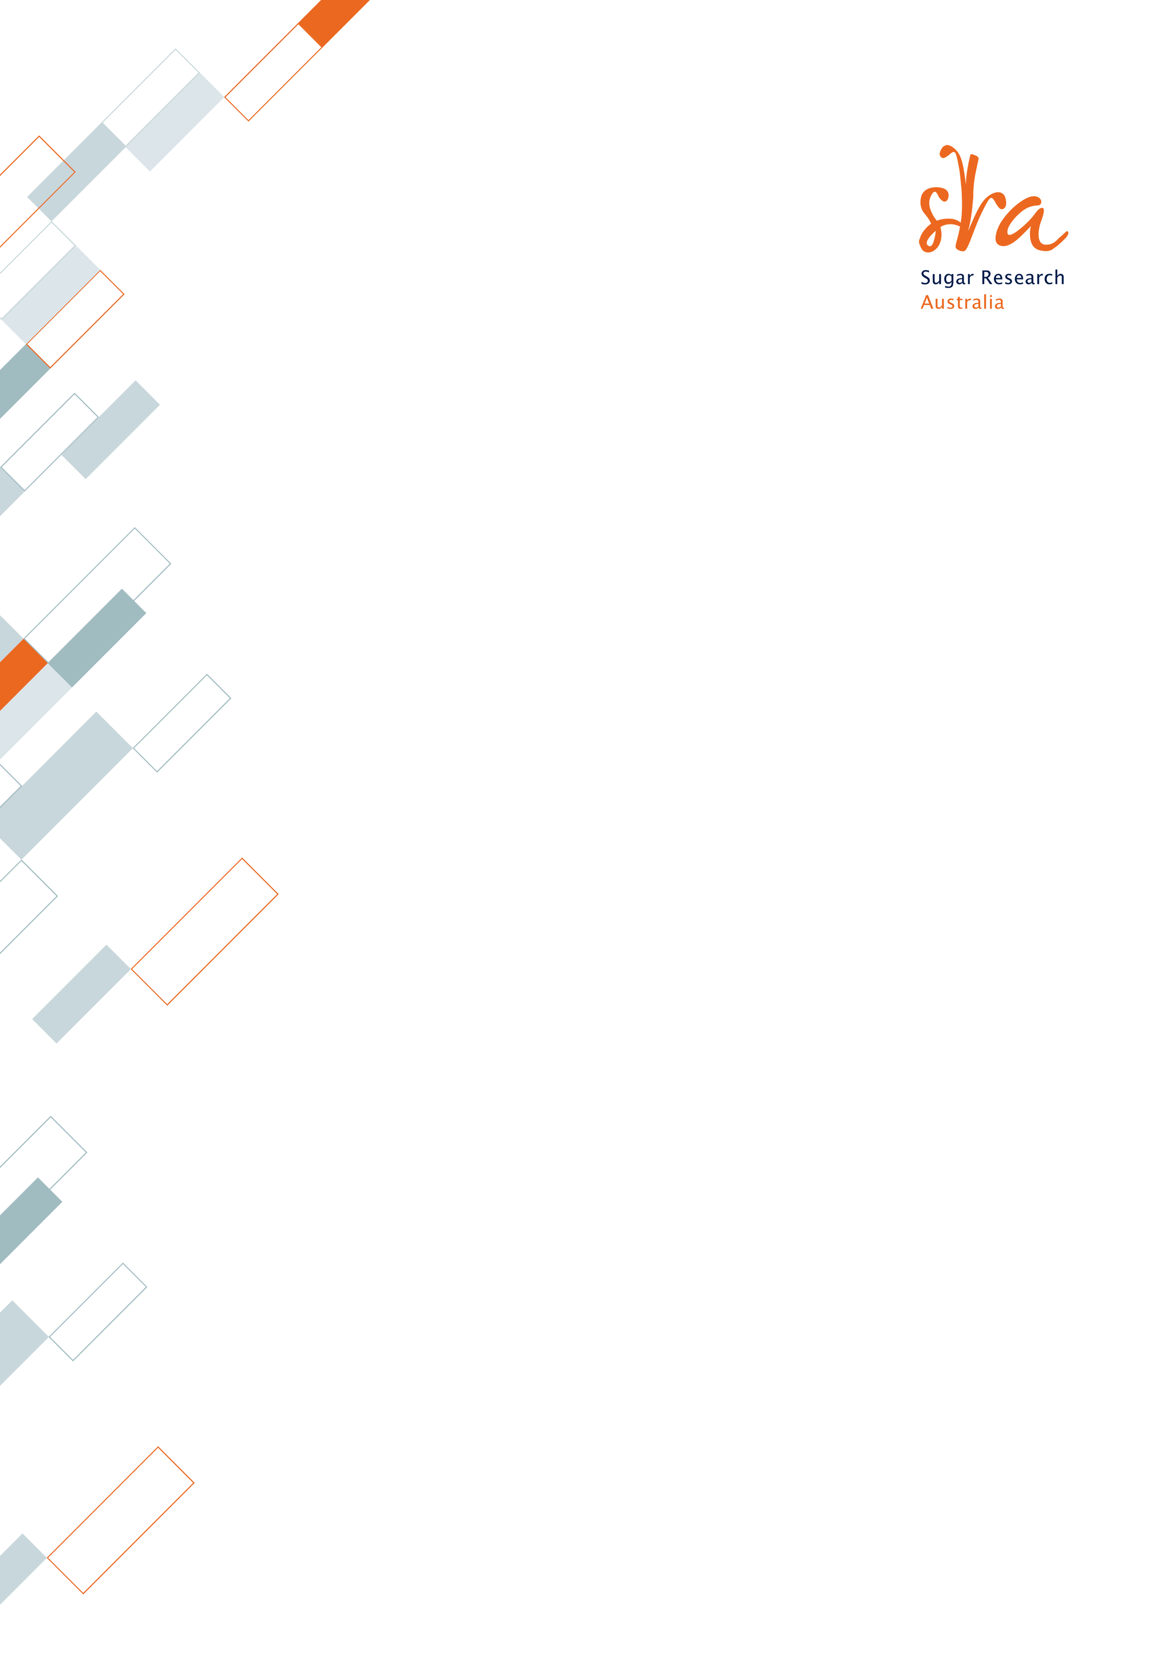

Final REPORT/ DOCUMENT HEADING TO GO HERE IN CAPS (ARIAL 40PT)

Final report prepared by
chief investigator(s)
research organisation(s)
co-funder
date
Research mission(S)
SRA Confidential <Delete textbox if not required>
Date of public access: xx/xx/xxxx <Delete textbox if not required>
Logo
Delete if not required
Logo
Delete if not required

© Copyright 2022 by Sugar Research Australia Limited.
Copyright in this document is owned by Sugar Research Australia Limited (SRA) or by one or more other parties which have provided it to SRA, as indicated in the document. With the exception of any material protected by a trademark, this document is licensed under a Creative Commons Attribution-NonCommercial 4.0 International licence (as described through this link). Any use of this publication, other than as authorised under this licence or copyright law, is prohibited.

This link takes you to the relevant licence conditions, including the full legal code.
In referencing this document, please use the citation identified in the document.
Disclaimer:
In this disclaimer a reference to “SRA” means Sugar Research Australia Ltd and its directors, officers, employees, contractors and agents.
This document has been prepared in good faith by the organisation or individual named in the document on the basis of information available to them at the date of publication without any independent verification. Although SRA does its best to present information that is correct and accurate, to the full extent permitted by law SRA makes no warranties, guarantees or representations about the suitability, reliability, currency or accuracy of the information in this document, for any purposes.
The information contained in this document (including tests, inspections and recommendations) is produced for general information only. It is not intended as professional advice on any particular matter. No person should act or fail to act on the basis of any information contained in this document without first conducting independent inquiries and obtaining specific and independent professional advice as appropriate.
To the full extent permitted by law, SRA expressly disclaims all and any liability to any persons in respect of anything done by any such person in reliance (whether in whole or in part) on any information contained in this document, including any loss, damage, cost or expense incurred by any such persons as a result of the use of, or reliance on, any information in this document.
The views expressed in this publication are not necessarily those of SRA.
Any copies made of this document or any part of it must incorporate this disclaimer.
Please cite as: Surname(s), Initial(s) (Year) Project title: Final Report Project Code. Sugar Research Australia Limited, Brisbane

ABSTRACT
Body Copy here
<Delete these guidelines prior to submission. Please do not change font styles. Abstract should provide a non-confidential plain-English summary of the project findings and implications in a form that can be communicated to industry and the media. What is that take home message? Maximum of 250 words.>

EXECUTIVE SUMMARY
Body Copy here
<Delete these guidelines prior to submission. Please do not change font styles. Executive summary should provide a non-technical overview of the project, outlining achievements in a form that can be communicated to the industry. It should not be more than 800 words. It should cover the following:
- Issue and objectives: What is the industry/community issue, what is its relevance, and how did the project address the issue?
- R&D methodology: Succinctly explain the methodology, and indicate the extent of collaboration and/or partnerships, especially with end users.
- The project outputs (i.e. knowledge, skills, processes, practices, products and/or technology).
- The outcomes and implications of the project findings on the sugar industry and the Australian community. Identify the industry benefits that will arise from the work. If possible, identify or estimate the realised/expected net benefits in terms of social, environmental and economic impact, and the realised/expected adoption of outputs. Indicate who will benefit from this research and where they are located in Australia.>

CONTENTS
ABSTRACT 1
EXECUTIVE SUMMARY 2
TABLE OF TABLES 4
TABLE OF FIGURES 4
1 BACKGROUND (Heading 1) 5
1.1 (Heading 2) 5
1.1.1 Sub heading (Heading 3) 5
2 PROJECT OBJECTIVES (Heading 1) 5
2.1 (Heading 2) 5
2.1.1 Subheading (Heading 3) 5
3 OUTPUTS, OUTCOMES AND IMPLICATIONS (Heading 1) 5
3.1 Outputs (Heading 2) 5
3.1.1 Heading 3 5
3.2 Outcomes and Implications 5
4 INDUSTRY COMMUNICATION AND ENGAGEMENT 6
4.1 Industry engagement during course of project 6
4.2 Industry communication messages 6
5 METHODOLOGY 6
5.1 Heading 2 6
6 RESULTS AND DISCUSSION 6
6.1 Heading 2 6
7 CONCLUSIONS 6
8 RECOMMENDATIONS FOR FURTHER RD&A 6
9 PUBLICATIONS 6
10 ACKNOWLEDGEMENTS 7
11 REFERENCES 8
12 APPENDIX 9
12.1 Appendix 1 METADATA DISCLOSURE 9
12.2 Appendix 2 10
13 SRA RESEARCH MISSIONS MANAGER, RESEARCH INVESMENT’S RECOMMENDATION 11

TABLE OF TABLES
Table 1 Metadata disclosure 1 9
Table 2 Metadata disclosure 2 9

<Insert Table of Figures here if required. Use “References > Insert Table of Figures”. Delete if not required.>

TABLE OF FIGURES
Figure Heading (Heading 6, Figure) 7

BACKGROUND (Heading 1)

(Heading 2)
Body Copy here

Sub heading (Heading 3)
Body Copy

(Heading 4)
Body Copy

(Heading 5)
Body Copy here
- Body Bullets
- Bullets

<Delete these guidelines prior to submission. Please do not change font styles. The background includes technical information and existing knowledge concerning the problem or research need addressed by the project. This section should provide a background and context of the project including
- Why it was undertaken?
- Its significance to the industry.
- How this project builds on previous research.>

PROJECT OBJECTIVES (Heading 1)

(Heading 2)
Body Copy here

Subheading (Heading 3)
<Delete these guidelines prior to submission. Please do not change font styles. This section must state the project objectives as worded in the research agreement.>

OUTPUTS, OUTCOMES AND IMPLICATIONS (Heading 1)

Outputs (Heading 2)
Body Copy here

Heading 3
<Delete these guidelines prior to submission. Please do not change font styles. This section should address the delivery of the project outputs identified at contracting and the adoption pathway of these outputs. Identify other outputs if applicable. Include the following:
- Detail further development (if any) of the output(s) that is required prior to adoption (for example, another project).
- Identify the target adoption audience of project outputs and detail how much adoption, if any, has taken place so far.
- If a third party or commercial party has been identified or will be required, please detail.>

Outcomes and Implications
Body Copy here
<Delete these guidelines prior to submission. Please do not change font styles. Address the outcomes (use and application of project outputs) and benefits (impact) of the project. Detail the implications and/or estimate the potential impact quantitatively and where, how and when these impacts have occurred or may occur. Address industry, environmental and social implications.>

INDUSTRY COMMUNICATION AND ENGAGEMENT

Industry engagement during course of project
Body Copy here
<Delete these guidelines prior to submission. Please do not change font styles. This section should answer the following:
- What key messages have come from the project to date, when and how have they been communicated and to whom? List the communication activities thus far. Has there been any communication with the relevant SRA Adoption Officer or Unit?
- What information, if any, is available on the adoption of project outputs?
- List any upcoming meetings, seminars, field days etc. associated with the project with a description.>

Industry communication messages
Body Copy here
<Delete these guidelines prior to submission. Please do not change font styles. This section should explain the industry and/or community communication message as a result of the project findings.>

METHODOLOGY

Heading 2
Body Copy here
<Delete these guidelines prior to submission. Please do not change font styles. Describe succinctly the key activities, methodologies used and experiments conducted during the course of this project to deliver the research outputs and achieve project objectives. This section should provide a full description of how the project was conducted including experimental design(s), measurements and statistical analysis.>

RESULTS AND DISCUSSION

Heading 2
Body Copy here
<Delete these guidelines prior to submission. Please do not change font styles. The results and discussion should include an overview of data and other relevant results. This section should include datasets with appropriate analysis. Use of graphs and tables to summarise data is encouraged. Project data should be included as an appendix. Full consideration and interpretation of the results is required. Structure should be clear and concise.
The discussion must provide sufficient evidence to substantiate the degree to which the project objectives have been achieved and/or the reasons why they have been modified or not achieved. The discussion should also include:
- Inferences and insights from the data relative to previous research.
- What didn’t work and what could have been done to improve project delivery.>

CONCLUSIONS
Body Copy here
<Delete these guidelines prior to submission. Conclusion goes here.>

RECOMMENDATIONS FOR FURTHER RD&A
What is needed, if anything, to further develop, disseminate, commercialise or exploit the Project Outputs?
What additional research is recommended to fully address the project objectives?

PUBLICATIONS
Body Copy here
<Delete these guidelines prior to submission. Please do not change font styles. List any academic publications or project publications (e.g. a manual or booklet) that have been published or are expected as a result of this project. Please do not attach journal articles or deep link to pdfs. Rather, provide the journal article Digital Object Identifier (DOI) if available.>

ACKNOWLEDGEMENTS
Body Copy here
<Delete these guidelines prior to submission. Please cite acknowledgements here.>
Table Heading Style (please use “TABLE HEADING” style for tables)
Table Data Heading
Table Data

Figure Heading (Heading 6, Figure)
Figure Caption (Caption, SRA Caption

REFERENCES
Body Copy here
<Delete these guidelines prior to submission. Please do not change font styles. Provide full alphabetised reference list as per Harvard reference guidelines.>

APPENDIX

Appendix 1 METADATA DISCLOSURE
<Delete these guidelines prior to submission. Please do not change font styles. Fill in the following details regarding the data generated in the course of this project. Provide details about the location, accessibility and contact details of those managing the data. Delete if not required.>
Table 1 Metadata disclosure 1
Data | (Description)
Stored Location | (I.e. organisation and server)
Access | (I.e. publicly accessible or restricted? Please provide details.)
Contact | (I.e. Details of person/position with access)

Table 2 Metadata disclosure 2
Data | (Description)
Stored Location | (I.e. organisation and server)
Access | (I.e. publicly accessible or restricted? Please provide details.)
Contact | (I.e. Details of person/position with access)

Appendix 2

SRA RESEARCH MISSIONS MANAGER’S RECOMMENDATION
(To be completed by the SRA Research Missions Manager, Research Investments)
Milestone Number
Milestone Title | Final Report
Final Report Due Date |  | Date submitted
Final Report Due Date |  | Date of submission of revised version (if relevant)
Date Reviewed |  | Date of review of revised version (if relevant)
Reason for delay
(if relevant)
Milestone Payment
Total Project Funding by SRA-RMS
Project Objectives
(Contracted)
Success in achieving the objectives | ☒ Completely Achieved  ☐ Partially Achieved  ☐ Not Achieved

SRA Research Missions Manager’s comments:

Project Outputs (brief version)

Activities to further develop, disseminate, commercialise or exploit the Project Outputs (after discussion with CI)

Recommendation:

