INTEGRATED WEED MANAGEMENT PLAN
DEMONSTRATION EXAMPLE
Enterprise Name: Albert Smith Family Trust
Farm No (s): Farm001 & Farm002
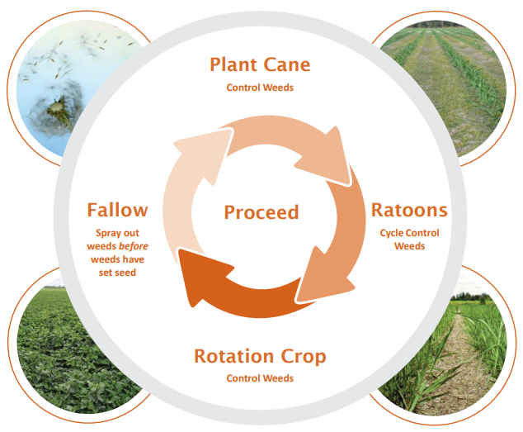




This is an example only. Use it to see the type of information you need to fill in the Integrated Weed Management template. The details in red are hypothetical. For additional information also read through the Guide to Integrated Weed Management Planning for Extension and Advisory Staff.

Chemical risk management

Environmental risks
- Slope risk
  - #Farm002 – blocks 1A, 2A and 3A have slopes >3% towards creek end of the blocks
- Proximity to waterways (<20m)
  - #Farm001 – blocks 1A and 5A
  - #Farm002 – blocks 1A and 2A
- Proximity to waterways (20-60m)
  - #Farm002 – blocks 3A and 9A
- Non target vegetation (<50m downwind)
  - #Farm001 – blocks 1A and 5A (riparian vegetation)
  - #Farm002 – blocks 1A, 2A, 3A, 6A and 9A (riparian vegetation)
  - #Farm002 – blocks 10A and 12A (fruit trees on residential land)
- Aquatic or wetland areas downwind (<25m)
  - #Farm001 – blocks 1A and 5A
  - #Farm002 – blocks 1A, 2A and 3A
- Aquatic or wetland areas downwind (25-100m)
  - #Farm002 – block 9A

Weeds present
Grass | Nutgrass/sedge | Broadleaf | Vine
☒ Guinea / Hamil  ☐ Couch grass  ☐ Summer grass  ☐ Wild sorghum  ☒ Crowsfoot grass  ☐ Barnyard grass  ☐ Awnless Barnyard grass  ☐ Feathertop Rhodes grass  ☐ Para grass  ☒ Green Summer grass  ☐ Sour grass | ☐ Nutgrass  ☒ Navua sedge  ☐ Other sedges | ☐ Square weed  ☐ Blackberry nightshade  ☐ Wild rose  ☒ Sicklepod  ☒ Blue top  ☐ Billygoat weed  ☐ Milkweed | ☐ Pink convolvulus  ☒ Red convolvulus  ☒ Calopo  ☐ Siratro  ☒ Balsam pear  ☐ Star of Bethlehem  ☐ Balloon vine

Weeds of National Significance (WoNS) or Locally Declared Weeds
- Nil

Management issues
- #Farm001
  - Block 1A – flooding and strong currents from creek and river
  - Block 2A – overflow from 1A when in flood
  - Block 3A – spoon drain constantly wet from underground springs
  - Block 4A – spoon drain constantly wet from underground springs, major drainage issues worse than 3A
  - Block 5A – poor drainage influenced by tides
  - Block 6A & 6B – Boundary drain (neighbouring property) often blocked which leads to flooding.
- #Farm002
  - No management issues

Aerial image showing farm boundary and proximity to waterways, riparian vegetation and drainage
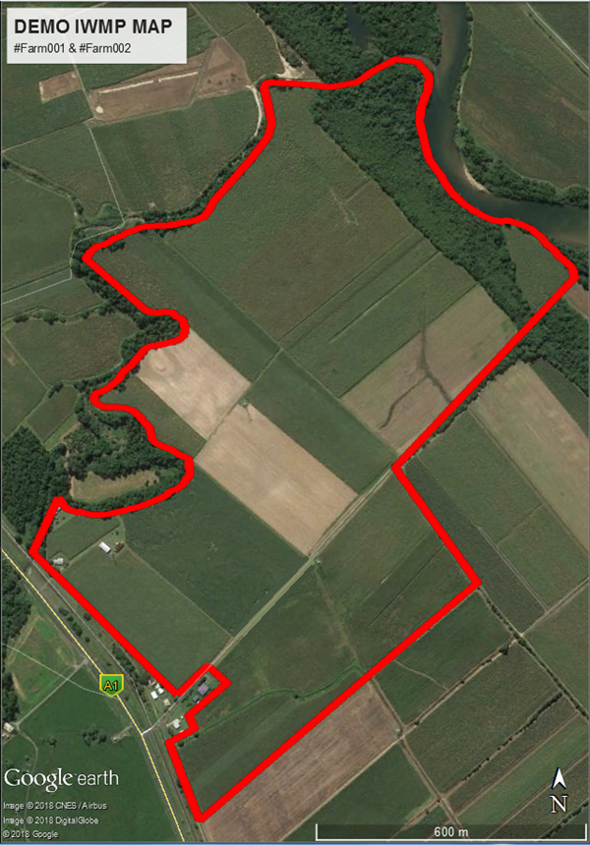

Farm maps showing location of flood prone areas and high weed pressure zones

Weed management strategies
What are the scenarios that are likely on your farm(s) and what is your management response?
Plant cane:
Situation 1 – tick activities that apply to this situation: Planting followed by fine weather | Situation 2 – tick activities that apply to this situation: Planting followed by wet weather
☒ First spray out of fallow (legume or weed/grass)  ☒ Second spray out of fallow (legume or weed/grass)  ☐ Third spray out of fallow (legume or weed/grass)  ☐ ☐ ☐ ☐ ☐ Cultivation/tillage zonal  ☒ ☒ ☒ ☐ ☐ Cultivation /tillage  ☒ Pre-emerge post plant  ☐ Weeder rake/cultivation post plant  ☒ Out of hand spray pre-emerge + knock down  ☐ Out of hand spray knock down only  ☐ Late pass pre-emerge + knock down  ☐ Late pass knock down only  ☒ Spot spray | ☐ First spray out of fallow (legume or weed/grass)  ☒ Second spray out of fallow (legume or weed/grass)  ☐ Third spray out of fallow (legume or weed/grass)  ☐ ☐ ☐ ☐ ☐ Cultivation/tillage zonal  ☒ ☒ ☒ ☐ ☐ Cultivation /tillage  ☒ Pre-emerge post plant  ☒ Weeder rake/cultivation post plant  ☒ Out of hand spray pre-emerge + knock down  ☐ Out of hand spray knock down only  ☐ Late pass pre-emerge + knock down  ☐ Late pass knock down only  ☒ Spot spray
Comments:  Planting followed by dry weather on these farms generally allows for good cane germination. This often leads to early canopy closure and less sunlight reaching the ground. | Comments:  Planting followed by wet weather on these low lying farms generally leads to poor germination. This can lead to an open canopy, resulting in more sunlight reaching the ground.

Situation 3 – tick activities that apply to this situation: Planting into a known dirty block (Guinea grass)
☒ First spray out of fallow (Guinea grass)
☒ Second spray out of fallow (Guinea grass)
☐ Third spray out of fallow (legume or weed/grass)
☐ ☐ ☐ ☐ ☐ Cultivation/tillage zonal
☒ ☒ ☒ ☐ ☐ Cultivation /tillage
☒ Pre-emerge post plant
☐ Post plant knockdown
☐ Weeder rake/cultivation post plant
☒ Out of hand spray pre-emerge + knock down
☐ Out of hand spray knock down only
☐ Late pass pre-emerge + knock down
☐ Late pass knock down only
☒ Spot spray

Will not plant legume or other cover crop. Maintain sprayed out fallow. Guinea grass is problematic as parts of the farm floods annually and re-seeds.
Use knockdowns in fallow at each guinea grass flush.

Ratoon cane:
Situation 1 – tick activities that apply to this situation: Poor soil moisture with no rain forecast (no irrigation) | Situation 2 – tick activities that apply to this situation: Poor soil moisture with rain forecast
☒ Utilise trash blanket after harvest  ☐ Pre-emerge after harvest  ☐ ☐ Cultivation  ☐ Banding of residuals/dual spray  ☐ Strategic (zones within block)  ☐ Utilise trash blanket at out of hand  ☐ Out of hand spray pre-emerge + knock down  ☒ Out of hand spray knock down only  ☐ Out of hand banding of residuals/dual spray  ☐ Out of hand strategic (zones within block)  ☐ Late pass pre-emerge + knock down  ☐ Late pass knock-down only  ☒ Spot spray | ☐ Utilise trash blanket after harvest  ☒ Pre-emerge after harvest  ☒ ☒ Cultivation  ☐ Banding of residuals/dual spray  ☐ Strategic (zones within block)  ☐ Utilise trash blanket at out of hand  ☐ Out of hand spray pre-emerge + knock down  ☒ Out of hand spray knock down only  ☐ Out of hand banding of residuals/dual spray  ☐ Out of hand strategic (zones within block)  ☐ Late pass pre-emerge + knock down  ☐ Late pass knock-down only  ☒ Spot spray
Comments:  Herbicide application delayed until out of hand stage due to weed germination/pressure being minimal as a result of dry conditions. | Comments:  Weed germination/pressure may be earlier in the ratoon cycle than if dry conditions persist.
Situation 3 – tick activities that apply to this situation: Good soil moisture with no rain forecast (no irrigation) |  | Situation 4 – tick activities that apply to this situation: Good soil moisture with rain forecast
☒ Utilise trash blanket after harvest  ☒ Pre-emerge after harvest  ☐ ☐ Cultivation  ☐ Banding of residuals/dual spray  ☐ Strategic (zones within block)  ☐ Utilise trash blanket at out of hand  ☐ Out of hand spray pre-emerge + knock down  ☒ Out of hand spray knock down only  ☐ Out of hand banding of residuals/dual spray  ☐ Out of hand strategic (zones within block)  ☐ Late pass pre-emerge + knock down  ☒ Late pass knock-down only  ☒ Spot spray |  | ☒ Utilise trash blanket after harvest  ☒ Pre-emerge after harvest  ☐ ☐ Cultivation  ☐ Banding of residuals/dual spray  ☐ Strategic (zones within block)  ☐ Utilise trash blanket at out of hand  ☒ Out of hand spray pre-emerge + knock down  ☐ Out of hand spray knock down only  ☐ Out of hand banding of residuals/dual spray  ☐ Out of hand strategic (zones within block)  ☐ Late pass pre-emerge + knock down  ☒ Late pass knock-down only  ☒ Spot spray
Comments:  Weed germination/pressure may be soon after harvest due to good soil moisture. |  | Comments:  Weed germination/pressure may be soon after harvest due to good soil moisture. Weed pressure may continue throughout the ratoon cycle.

Note:
These are the likely scenarios that can occur on the farm, with associated strategies to deal with them.
Actual herbicide product selection will be done prior to spray job when exact conditions are known.
Situation 5 – tick activities that apply to this situation: Prolonged flooding expected
☒ Utilise trash blanket after harvest
☐ Pre-emerge after harvest
☐ ☐ Cultivation
☐ Banding of residuals/dual spray
☐ Strategic (zones within block)
☐ Utilise trash blanket at out of hand
☐ Out of hand spray pre-emerge + knock down
☐ Out of hand spray knock down only
☐ Out of hand banding of residuals/dual spray
☐ Out of hand strategic (zones within block)
☐ Late pass pre-emerge + knock down
☒ Late pass knock down only
☒ Spot spray

Comments:
Pre-emergents likely to be ineffective.
Plan on aerial vine control only. If access to the paddock is possible, spot spraying may be considered.

Fallow management strategies
- Allow cane to ratoon until late February/early March to ensure cover over the wet season
- First spray out in late February/early March
- Second spray out late April/early May to control volunteers
- Begin land preparation in late May/early June, depending on fine weather.

Weed harbourages and sources
Strategy | Area
Spray weeds with appropriate chemicals | Along train lines
Revegetate area to reduce weed pressure
Slash before grasses set seed | Headlands
Talk to other land owners about community based solution | Talk to Queensland Rail and the mill about weeds long train and tram lines
Ensure clean machinery
Other

